Contents

I. ENVIRONMENT 2

1. Virtual Machine: 2

2. Install Ganache on Windows 11 to create a simulated blockchain and develop DApp (decentralized application): 2

3. Install Truffle Suite on Windows to write, compile, test and deploy smart contracts on the Ethereum blockchain. 4

4. Install MetaMask plugin for Chrome, Firefox or Safari 6

II. WRITING THE SMART CONTRACT CODE 10

Step 1: Chuẩn bị môi trường 10

Step 2: Install OpenZeppelin in project by npm 10

Step 3: Write a contract ERC20 (MoolahCoin) 11

Step 4: Write ERC721 Contract (Condos) 13

III. MIGRATING THE SMART CONTRACT CODE USING TRUFFLE 14

Step 1: Bring your Ganache blockchain online 14

Step 2: Migrate the contracts we wrote earlier to our Ganache blockchain network 15

IV. CREATING THE TOKEN WALLET FRONTEND USING REACTJS 22

Step 1: Setting up the React app 23

Step 2: Adding token interfaces to our app 26

Step 3: App components 28

Step 4: Running our app 39

V. CONNECTING TO THE MAIN ETHEREUM NETWORK 46

# I. ENVIRONMENT

## 1. Virtual Machine:

- Download and Install VirtualBox: <https://www.virtualbox.org/wiki/Downloads>

- Download Windows 11 Enterprise (choose 64-bit edition): <https://www.microsoft.com/en-us/evalcenter/download-windows-11-enterprise>

Or <https://github.com/IPv4v6/linklists/blob/master/windows.md>

- Create Virtual machine **Windows 11** in Virtual Box

- Connect Windows 11 machine to the Internet.

- Install and configure to be able to copy/paste text from physical machine to virtual machine

## 2. Install Ganache on Windows 11 to create a simulated blockchain and develop DApp (decentralized application):

**Step 1: Download Ganache**

1. Click on Link: <https://trufflesuite.com/ganache>
2. Choose **"Download Ganache"**
3. Download version for **Windows** (file .exe)

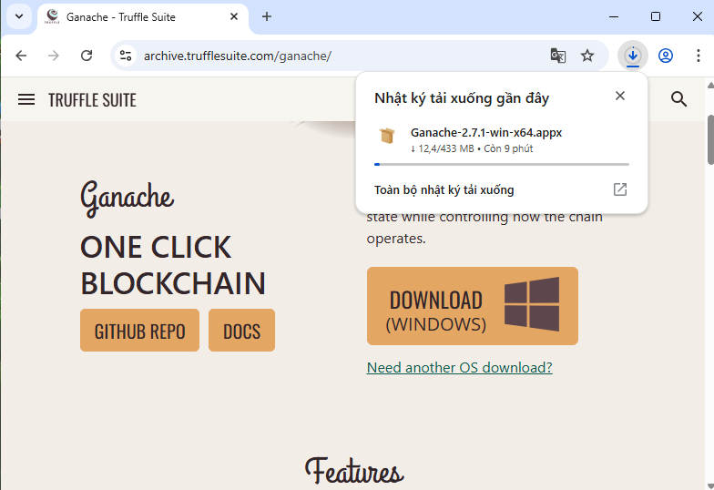

#### ****Step 2: Install Ganache****

1. Open file .exe you have just downloaded
2. 2. Follow the installation steps as usual:
   * Select "Next"
   * Accept the terms
   * Select the installation folder (can be left as default)
   * Select "Install" → Then "Finish"

#### ****Step 3: Run Ganache****

* Open Ganache from **Start Menu** or on Desktop Shortcut
* Choose:
  + **"Quickstart Ethereum"** to create simulated blockchain Ethereum

Or choose **"New Workspace"** to customize (advanced)

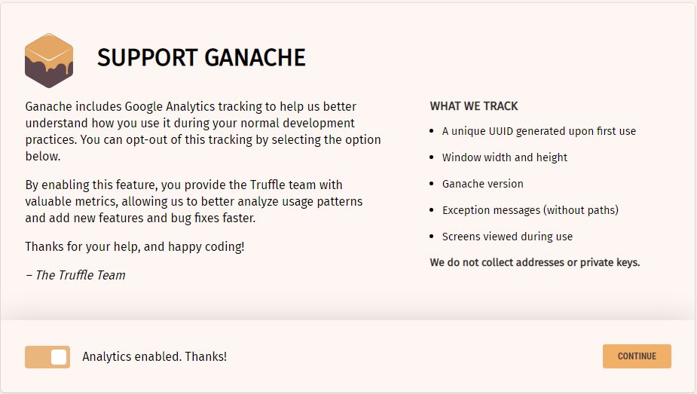 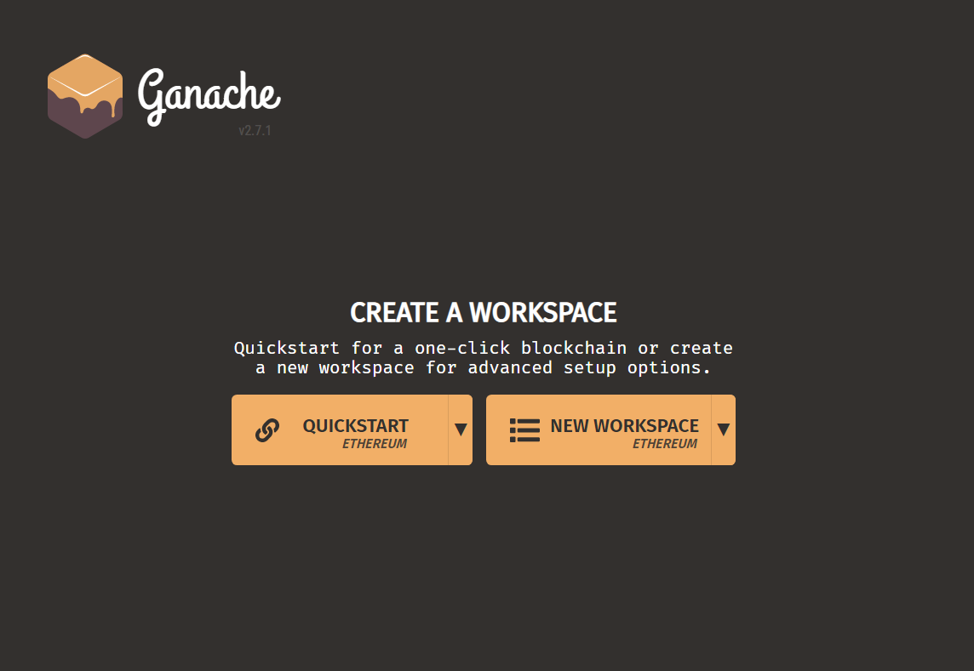

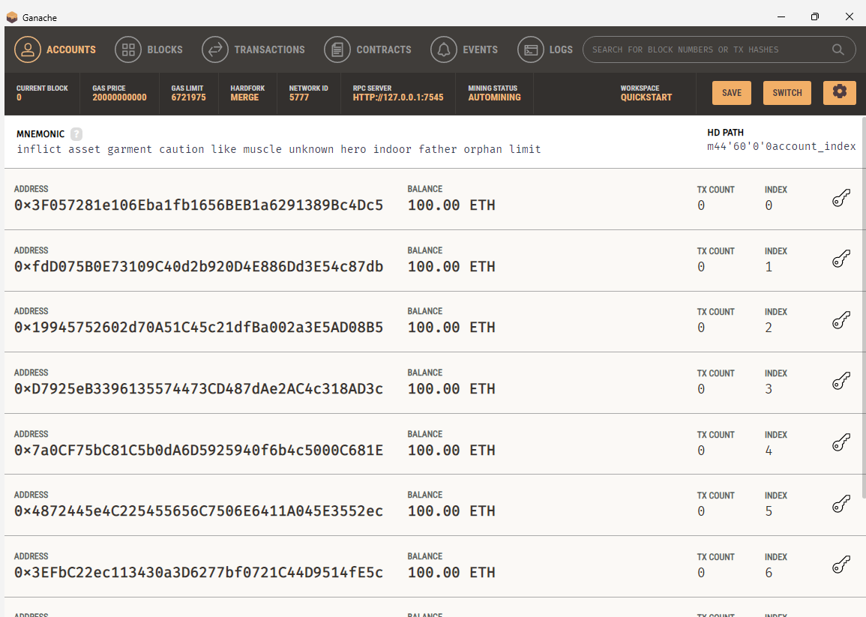

**Key Features When You Open Ganache**

* **Automatically Create 10 Ethereum Accounts (With 100 Fake ETH)**
* **View Interface:**
* **Blocks and Transactions**
* **Deployed Smart Contracts**
* **Events and Logs**
* **Integrate with Truffle and MetaMask**

|  |  |  |
| --- | --- | --- |
| **Requirement** | **Components on Ganache Interface** | **Integrated with** |
| Connect backend/contract | RPC SERVER, Network ID | Truffle |
| Connect wallet | RPC SERVER, Mnemonic, Private Key | MetaMask |

#### ****Note:****

* When running blockchain projects, use HTTP RPC port 7545 (Ganache default)
* Connect MetaMask to http://127.0.0.1:7545
* Use a fake ETH account to test free transactions

## 3. Install Truffle Suite on Windows to write, compile, test and deploy smart contracts on the Ethereum blockchain.

Truffle is a powerful framework that makes it easy to develop DApps by:

* Compiling smart contracts (Solidity)
* Deploying to blockchain (Ganache, testnet, mainnet)
* Writing tests for smart contracts
* Integrating with frontends like ReactJS

#### ****Step 1: Install Node.js and npm****

Because Truffle run by Node.js so you should install Node.js first:

1. Go to the link: <https://nodejs.org/>
2. Download **LTS version** (recommended)

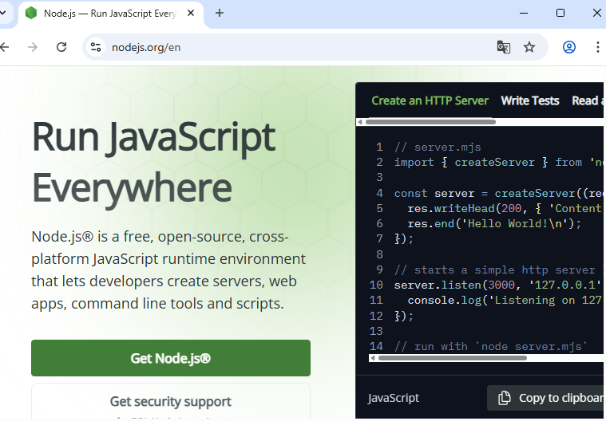 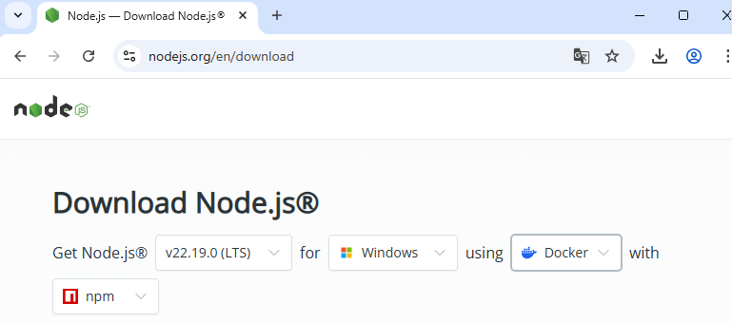

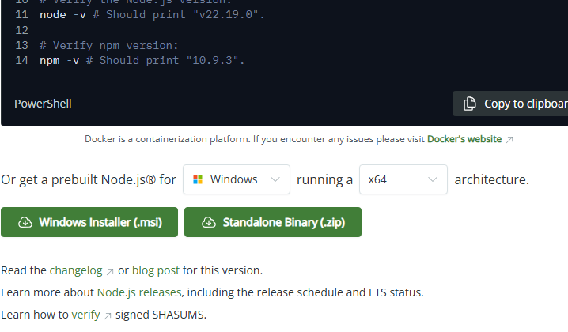

1. Install Node.js

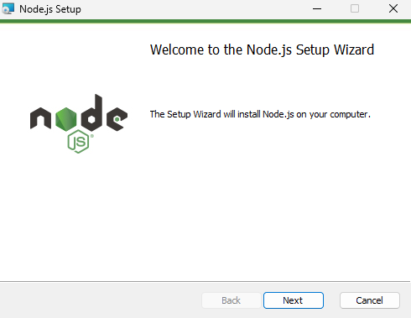 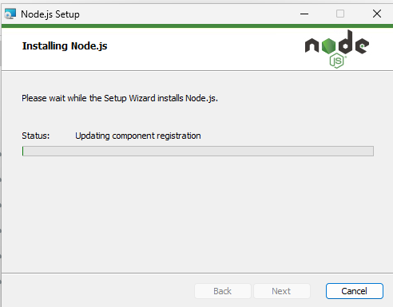

1. Check the installation by opening **Command Prompt (cmd)** and typing:

node -v

npm -v

If you see the version displayed (eg v22.17.1), it means the installation was successful.

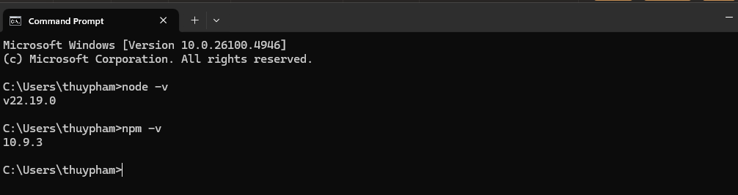

#### 

#### ****Step 2: Intall Truffle by npm****

After installing Node.js, you install Truffle by the following comand:

npm install -g truffle

(-g is for global installation)

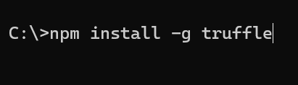

Update npm:

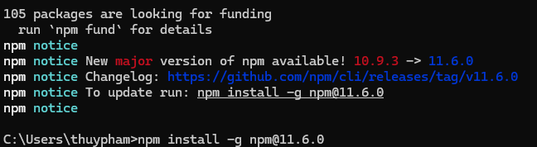

#### ****Step 3: Check Truffle installation****

truffle version

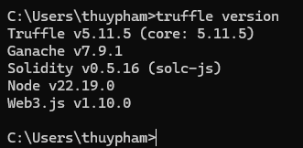

#### ****Note****

* Integrate with **Ganache** to run blockchain locally
* Integrate with **MetaMask** to test transactions
* Use **OpenZeppelin** library to write secure smart contracts

## 4. Install MetaMask plugin for Chrome, Firefox or Safari

MetaMask is a popular Ethereum wallet for account management and inter act with blockchain.

MetaMask is a browser plugin (Chrome/Firefox) that acts as an Ethereum wallet. It allows:

• Managing multiple wallet accounts

• Signing and sending transactions

• Interacting with DApps (e.g. Truffle DApp, Uniswap)

• Connecting to real blockchain networks (Mainnet), simulated (Ganache), or testnets (Goerli, Sepolia)

**Step 1: Visit official site**

- <https://metamask.io/>

- Click GET METAMASK → Add to Chrome → Select “**Add extension**”

**METAMASK is added to Chrome Browser**

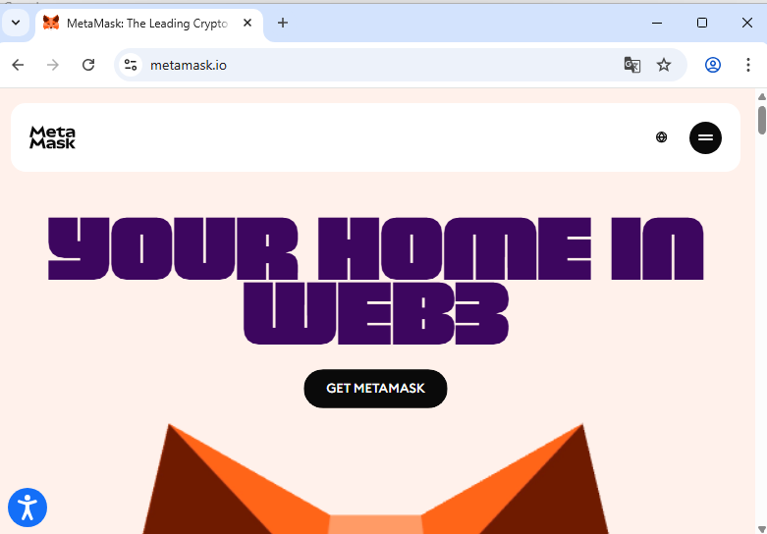

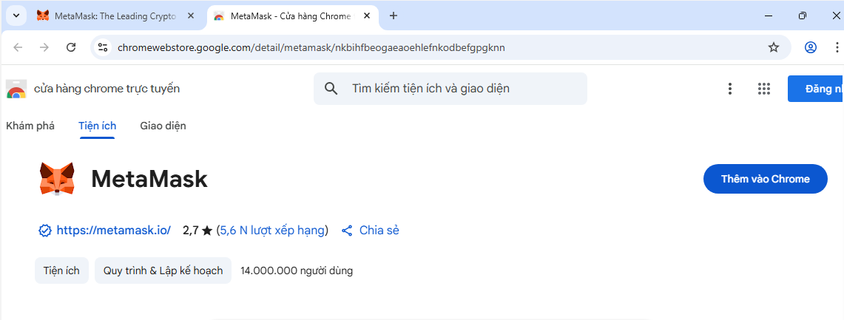

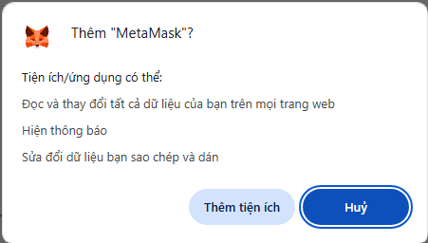

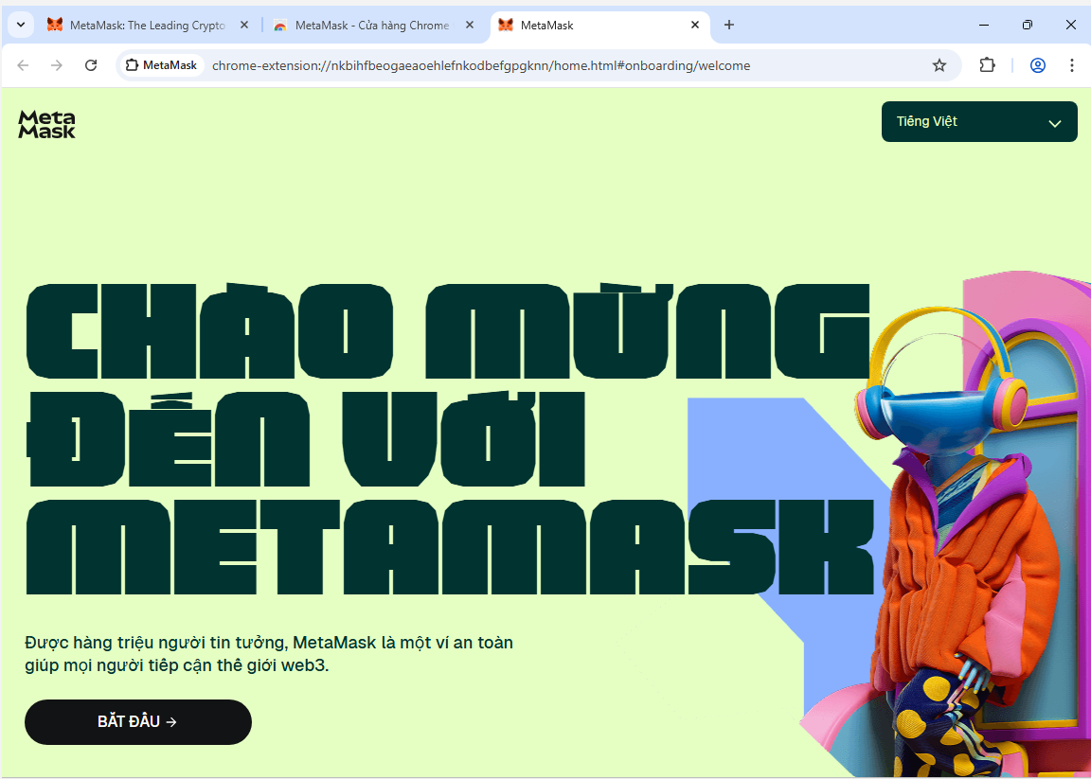

**Step 2: Create or Restore Wallet**

**After Installation:**

1. Click on MetaMask icon on the browser
2. Choose **“Get Started”**
3. Choose one of these:
   * o Create a Wallet → create a new wallet
   * o Import Wallet → restore wallet with 12 seed keywords

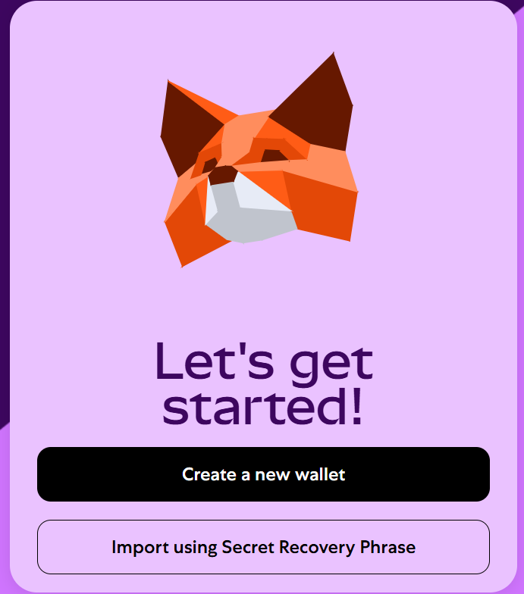

1. Set password **→ Record and secure 12 recovery words**

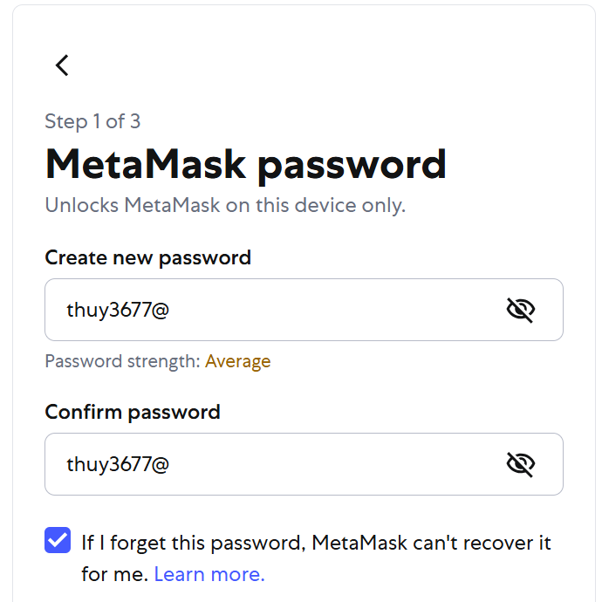 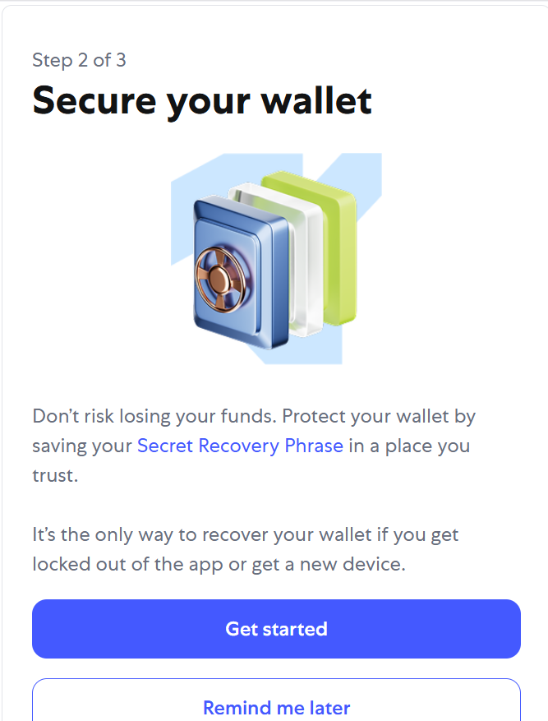 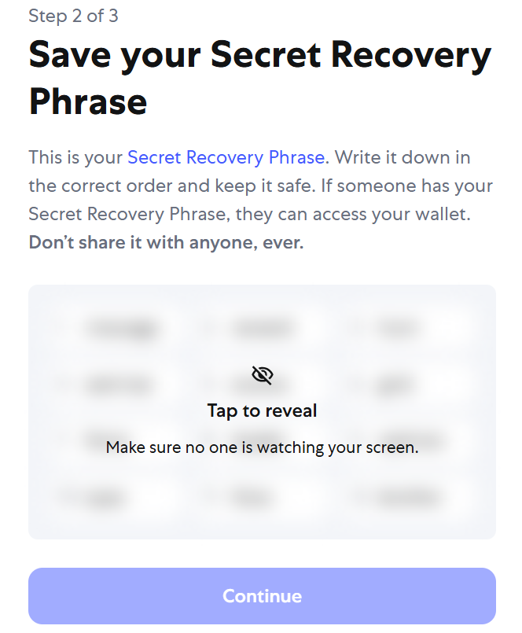

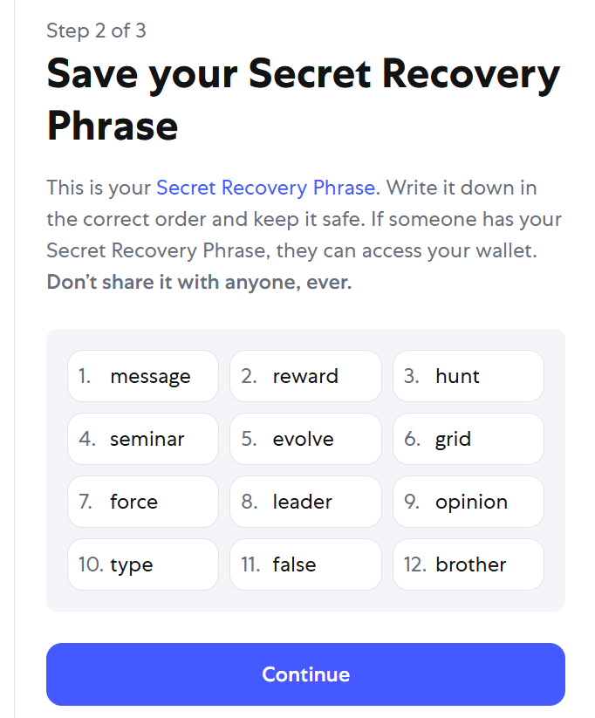

(Steps from left to right)

**Note:**

• You can manually add **Ganache network** (RPC URL: http://127.0.0.1:7545) to connect **MetaMask** wallet to simulated blockchain

• Use **MetaMask** to sign transactions from **ReactJS** frontend or **Dapp**

# II. WRITING THE SMART CONTRACT CODE

**Objectives**

* **Create ERC20 token: MoolahCoin (payment token)**
* **Create ERC721 token: Condos (apartment ownership token)**
* **Write smart contracts in Solidity**
* **Use OpenZeppelin 2.2 to reuse standard templates, increase security**
* **Test and deploy on Ganache using Truffle Suite**

## ****Step 1: Chuẩn bị môi trường****

1. **Intall Node.js & npm (done in part I section 1-3)**
2. **Intall Truffle (global) (done in part I section 1-3)**
3. **Intall Ganache (desktop) (done in part I section 1-3)**
4. **Create project folder và init Truffle**

**mkdir** tokenwallet

**cd** tokenwallet

truffle init

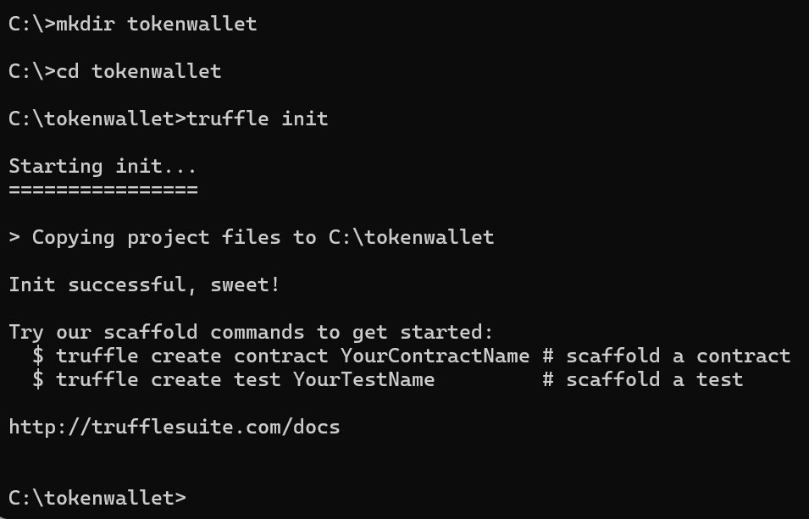

## ****Step 2: Install OpenZeppelin in project by npm****

In the project root directory (with truffle-config.js), run:

npm init –y

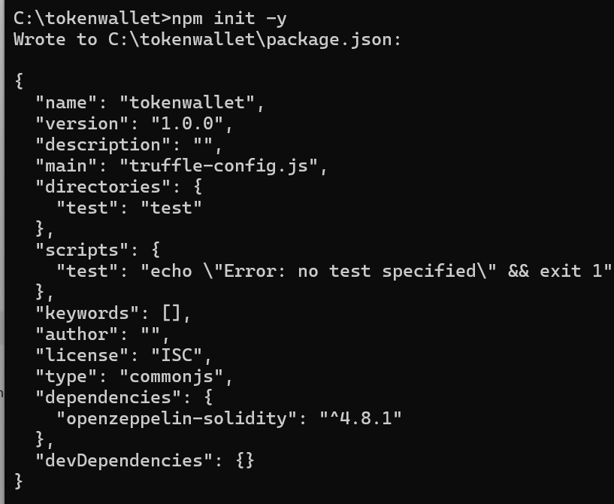

npm install @openzeppelin/contracts

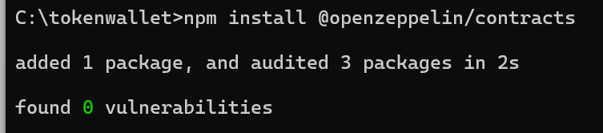

## ****Step 3: Write a contract ERC20 (MoolahCoin)****

1. In folder **contracts** of the proje ct folder **Tokenwallet**, create file: contracts/MoolahCoin.sol

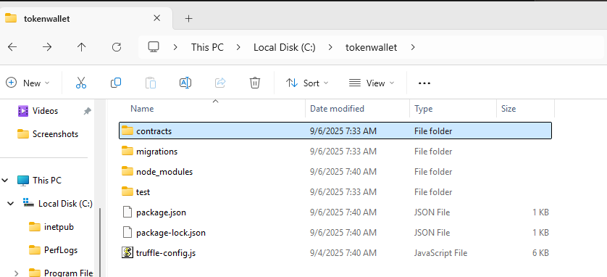

1. Create MoolahCoin.sol on **Remixx** and then copy this file to the folder contracts

**Bước 1: Mở Remix:** Truy cập: <https://remix.ethereum.org>

**Bước 2: Tạo file mới**

1. Click vào biểu tượng **File Explorer** bên trái.
2. Click nút **"New File"** ➕
3. Đặt tên file là MoolahCoin.sol

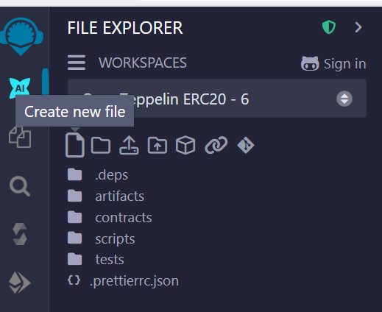 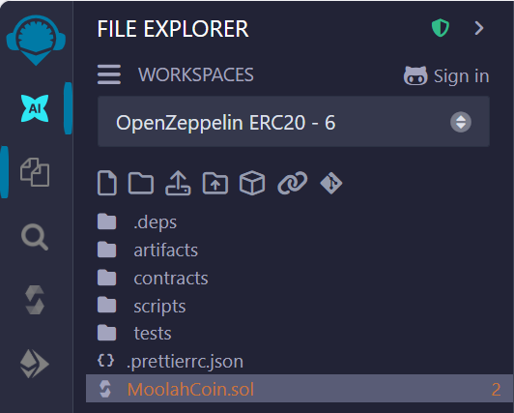

**Bước 3: Viết mã ERC20 Token**

**Bước 4: Biên dịch hợp đồng**

1. Click vào tab **Solidity Compiler** (thanh công cụ bên trái).
2. Đảm bảo chọn **Version** là 0.8.20 (hoặc tương thích).
3. Click **Compile** MoolahCoin.sol

**(Solidity ^0.8.20, OpenZeppelin V5)**

|  |
| --- |
| // SPDX-License-Identifier: MIT  pragma solidity ^0.8.20;  import "@openzeppelin/contracts/token/ERC20/ERC20.sol";  import "@openzeppelin/contracts/token/ERC20/extensions/ERC20Capped.sol";  import "@openzeppelin/contracts/access/Ownable.sol";  contract MoolahCoin is ERC20, ERC20Capped, Ownable {      constructor(address initialOwner)          ERC20("Moolah Coin", "MC")          ERC20Capped(10_000_000_000 * 10 ** 4)          Ownable(initialOwner)      {          _mint(initialOwner, 1_000_000 * 10 ** 4);      }      function decimals() public pure override returns (uint8) { return 4; }      // bắt buộc khi kết hợp ERC20 + ERC20Capped trong OZ v5      function _update(address from, address to, uint256 value)          internal          override(ERC20, ERC20Capped)      { super._update(from, to, value); }  } |

## ****Step 4: Write ERC721 Contract (Condos)****

1. Create file: contracts/Condos.sol

|  |
| --- |
| // SPDX-License-Identifier: MIT  pragma solidity ^0.8.20;  import "@openzeppelin/contracts/token/ERC721/extensions/ERC721URIStorage.sol";  import "@openzeppelin/contracts/access/Ownable.sol";  contract Condos is ERC721URIStorage, Ownable {      uint256 private _nextTokenId;      constructor(address initialOwner)          ERC721("Condo Ownership Token", "CONDOS")          Ownable(initialOwner)      {}      function mint(address to, string calldata uri)          external          onlyOwner          returns (uint256 tokenId)      {          tokenId = _nextTokenId++;          _safeMint(to, tokenId);          _setTokenURI(tokenId, uri);      }  } |

# III. MIGRATING THE SMART CONTRACT CODE USING TRUFFLE

**Migration is the process of deploying the compiled smart contract to the test or real blockchain using Truffle.**

**Before using the smart contract, we need to deploy (migrate) it to the test blockchain (for example Ganache).**

**The migration process performs the following tasks:**

* **Deploy** the compiled contract code to the blockchain.
* **Connect dependent contracts together** (if any).
* **Initialize the initial value** via the contract constructor.
* **Manage contract versions:** In Ethereum, each time a contract is deployed, a new address is created → very difficult to manage => Truffle simplifies by allowing you **to call the contract via the object, without knowing the specific address.**

=> **Truffle migrate** helps:

* Deploy smart contracts professionally.
* No need to worry about updating contract addresses every time you redeploy.
* Easy to control version and structure as the project grows.

## ****Step 1:**** Bring your Ganache blockchain online

To deploy the smart contracts, first bring your Ganache blockchain online. Make sure your Ganache test server is running on localhost:8545. To do so, select the **New Workspace** option from the Ganache launch screen. Click on the **SERVER** tab on the **Workspace** screen. Set the port number to 8545:



Click on **Save Workspace** in the upper-right corner. A blockchain network will be started as follows:



## Step 2: Migrate the contracts we wrote earlier to our Ganache blockchain network

1. We start with creating migrations for the two token contracts using the Truffle command line, as shown here:

truffle console

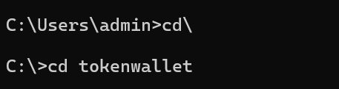

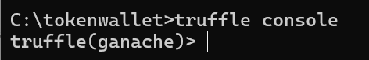

truffle(development)> create migration condos_migration

truffle(development)> create migration moolahcoin_migration

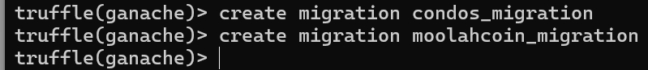

Two migration files will be created with the following nomenclature:

*{timestamp}_moolahcoin_migration.js

*{timestamp}_condos_migration.js

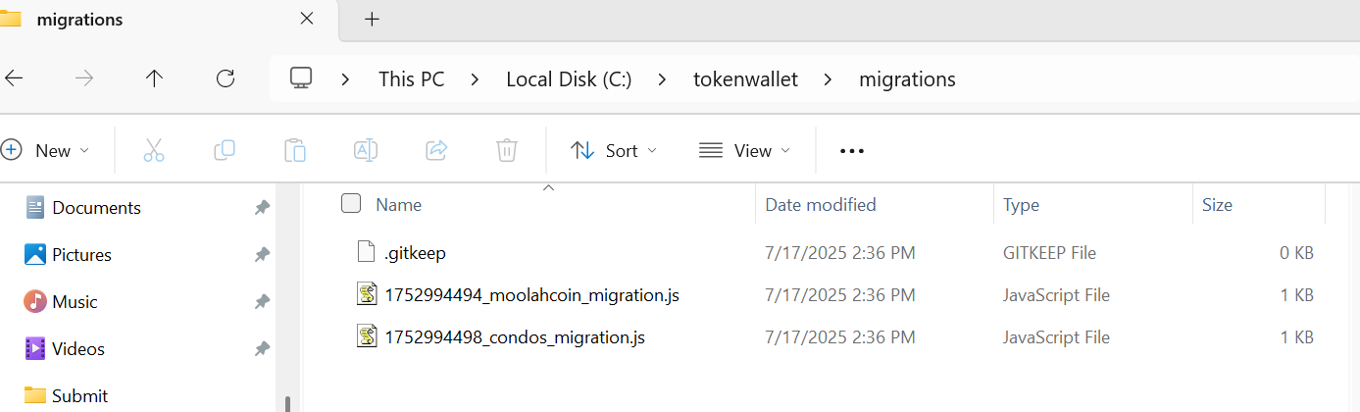

2. Replace the content of the *{timestamp}_moolahcoin_migration.js file with the following code:

|  |
| --- |
| // migrations/2_deploy_moolahcoin.js  const MoolahCoin = artifacts.require("MoolahCoin");  module.exports = async (deployer, network, accounts) => {  await deployer.deploy(MoolahCoin, accounts[0]);  }; |

3. Replace the content of the *{timestamp}_condos_migration.js file with the following code:

|  |
| --- |
| const Condos = artifacts.require("Condos");  module.exports = async function (deployer, network, accounts) {  await deployer.deploy(Condos, accounts[0]); // owner ban đầu  }; |

4. Complile contracts (MoolahCoin.sol, Condos.sol) and migrate on Truffle

|  |
| --- |
| truffle compile --all  # reset workspace Ganache (Save & Restart), then:  truffle migrate --network ganache --reset |

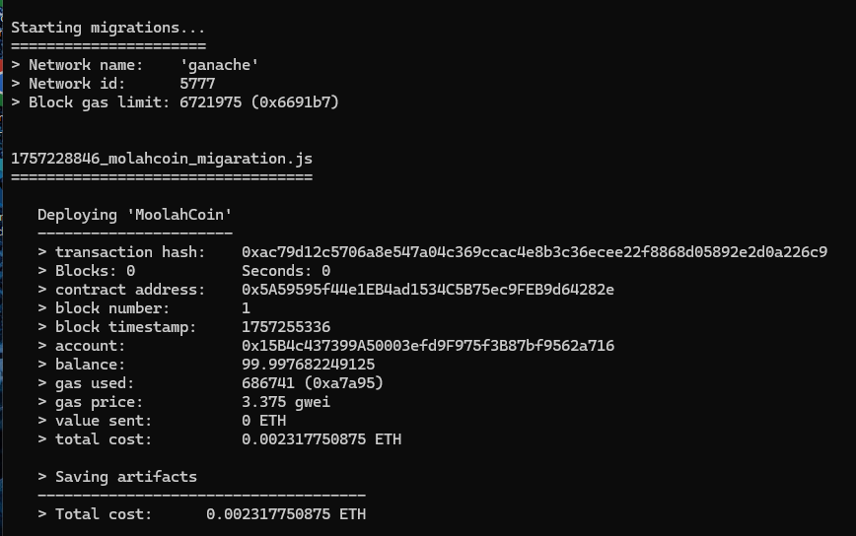

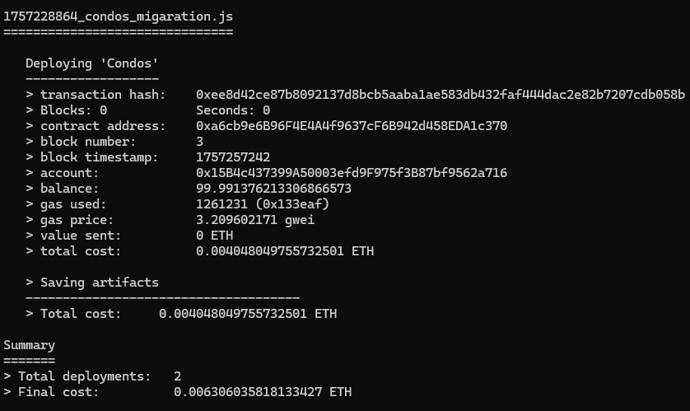

5. Now, check the Ganache UI. It will show that some blocks have been mined and the transactions have been created:

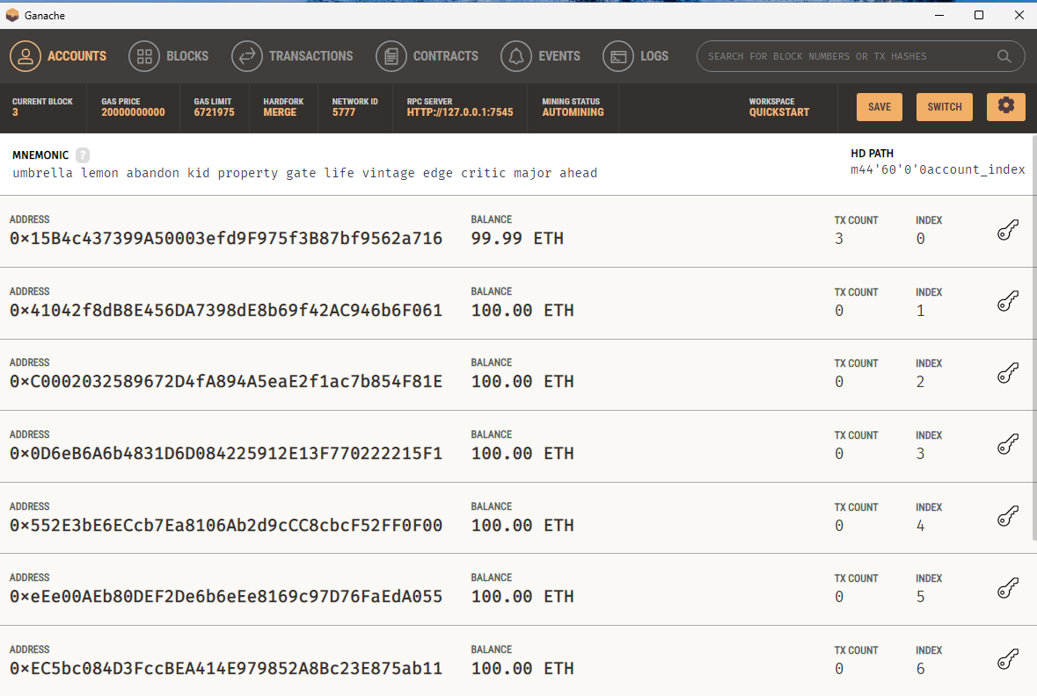

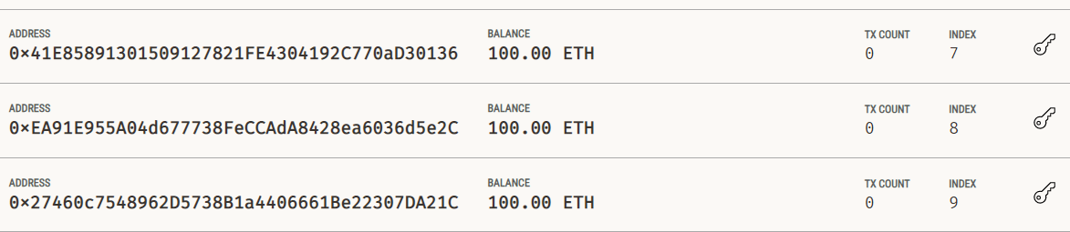

Looking at the Ganache results, the migrations ran successfully, and here’s what each part means:

**- Tab ACCOUNTS**

* **ACCOUNT 0 (index 0) has 99.99 ETH & TX COUNT = 3**  
  → This is the wallet Truffle used to deploy (accounts[0]). It signed three transactions:
  1. Deploy **Migrations** (Truffle’s default)
  2. Deploy **MoolahCoin**
  3. Deploy **Condos**  
     The balance dropped from 100 → 99.99 ETH because of gas fees for those three transactions (gas price shown as **2 gwei**).
* **Other accounts still have 100 ETH, TX COUNT = 0**  
  → They weren’t used—no transactions sent or received yet.
* **Top info bar:**
  1. **GAS PRICE** = 2,000,000,000 wei (**2 gwei**)
  2. **GAS LIMIT** ≈ 6,721,975 (Ganache default)
  3. **HARDFORK** = **MERGE** (equivalent to **Paris**)
  4. **RPC SERVER** = http://127.0.0.1:7545 (your truffle-config should point to this port)
  5. **MINING STATUS: AUTOMINING** → each transaction is mined immediately.
* **MNEMONIC & HD PATH m/44'/60'/0'/account_index**  
  → The 10 addresses below are derived from this 12-word seed using the HD wallet standard. You can import each account’s private key into MetaMask for testing.

**- Tab TRANSACTIONS**

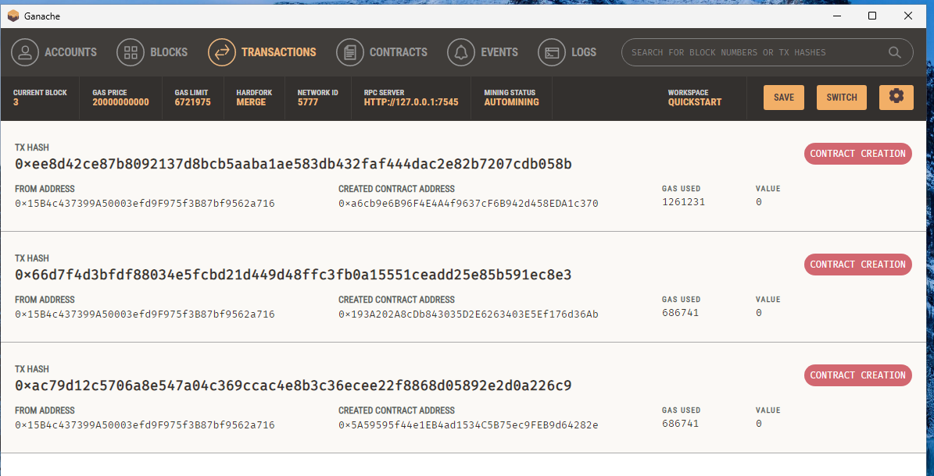

**Each transaction card (newest → oldest)**

* **TX HASH:** the transaction hash (click to see details).
* **FROM ADDRESS:** the sender address (your deployer wallet – accounts[0]).
* **CREATED CONTRACT ADDRESS:** the address of the newly created contract → this is a **CONTRACT CREATION** tx.
* **GAS USED:** actual gas consumed by the transaction.
* **VALUE:** ETH attached (usually 0 when deploying contracts).

**In the screenshot there are three** CONTRACT CREATION **transactions:**

1. Deploy **Migrations** (Truffle default) – gas used **1,261,231**  
   Cost ≈ 1,261,231 × 2e9 wei = **0.002522462 ETH**
2. Deploy **MoolahCoin** – gas used **686,741**  
   Cost ≈ **0.001373482 ETH**
3. Deploy **Condos** – gas used **686,741**  
   Cost ≈ **0.001373482 ETH**

**- Tab CONTRACTS**

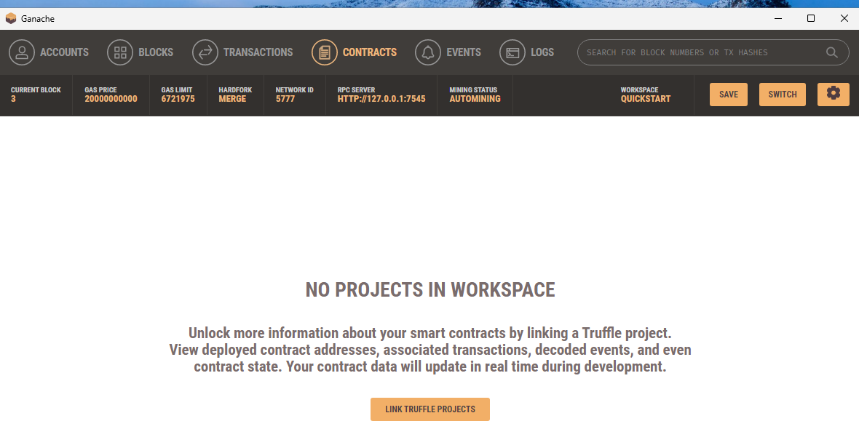

The **CONTRACTS** tab in Ganache only shows contract names + ABI when Ganache is **linked to a Truffle project**. You’re in the “Quickstart” workspace without a link, so it shows **NO PROJECTS IN WORKSPACE**.

How to show the contract list (name + address + ABI)

1. Go to **CONTRACTS** → click **LINK TRUFFLE PROJECTS**.
2. Select your project’s truffle-config.js (e.g., C:\tokenwallet\truffle-config.js).
3. Make sure the project has been **compiled/migrated** so build/contracts/*.json exists.
4. Click **Save & Restart** (top-right) so Ganache loads the ABIs and maps them to the created transactions.
5. Return to **CONTRACTS** → you’ll see **Migrations / MoolahCoin / Condos** with addresses, and you can view ABI, events, and storage.

**The results:** MoolahCoin and Condos are deployed

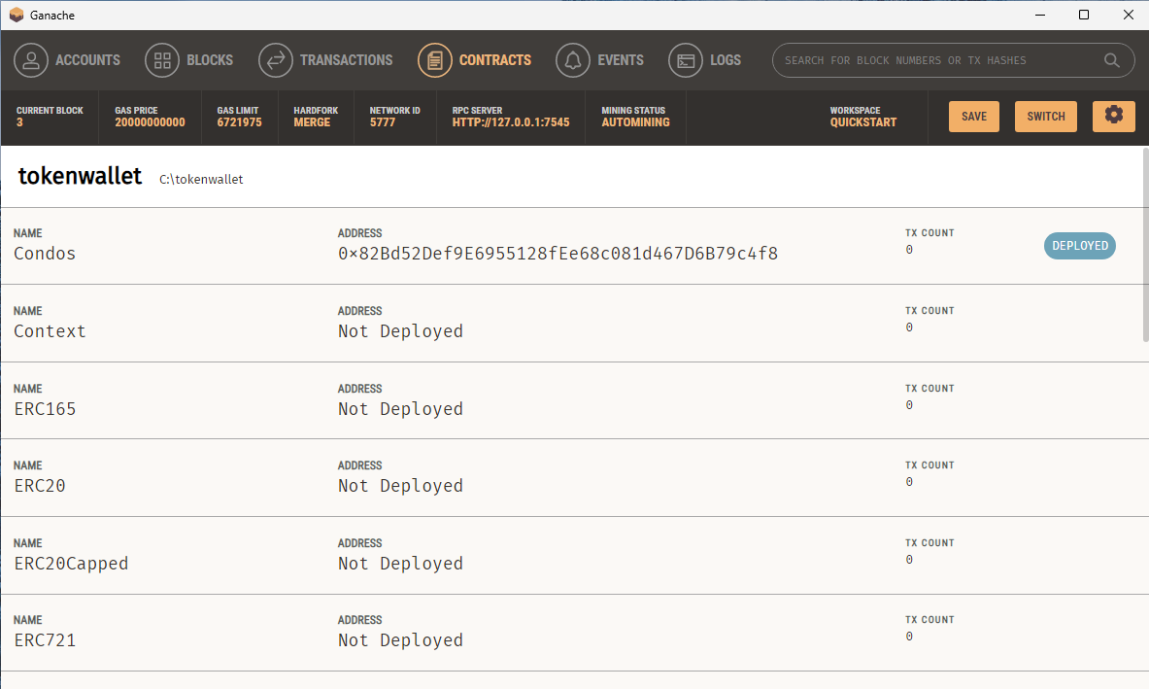

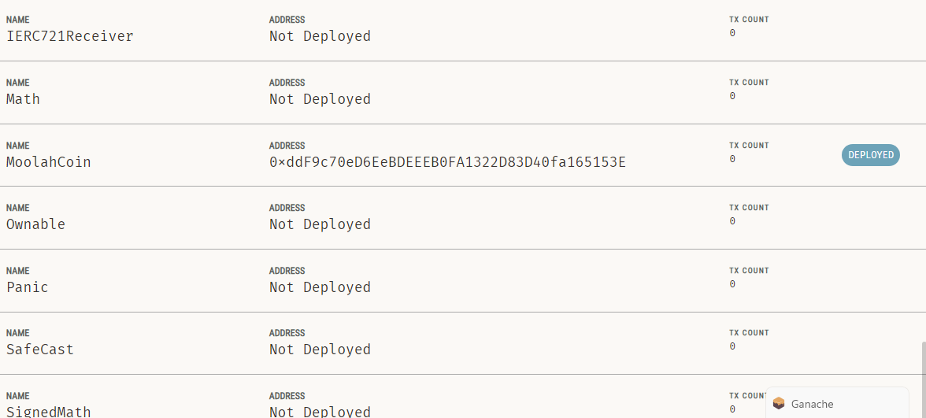

# IV. CREATING THE TOKEN WALLET FRONTEND USING REACTJS

This wallet will allow users to **view token balances**, **send/receive ERC20/ERC721 tokens**, and **interact with MetaMask and the Ethereum network**.

We need to set up a MetaMask account before we can create our wallet frontend. To do so, follow these steps:

1. Start by installing MetaMask into your browser. It's available as a plugin for Chrome and Firefox. Create or import your wallet using the seed words.

2. Open the MetaMask wallet by clicking on the icon on the right-hand side. On the top right hand side of your Chrome or Firefox browser for test account. From the drop-down menu for the **network** tab in MetaMask, select the network as Localhost 7545. If it’s not there yet, add it manually as follows:

- Click the drop down arrow on Ethereum Mainnet -> Add a custom network -> Network name: **Ganache**; Default RPC URL: <http://127.0.0.1:7545> -> Chain ID: 1337; Currency Symbol: ETH; Block Explorer: để trống => ấn Save.

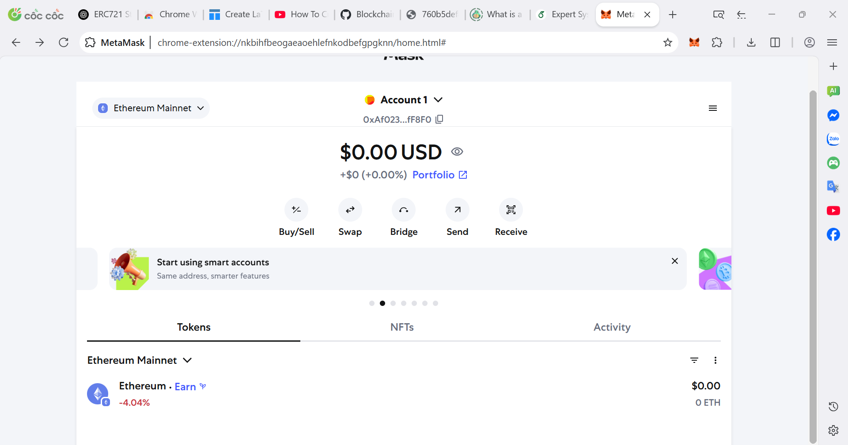 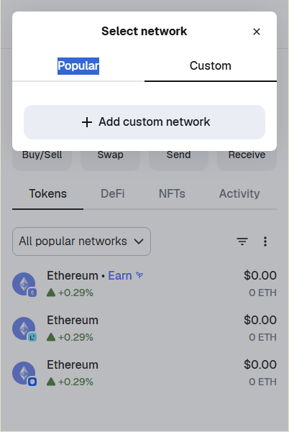

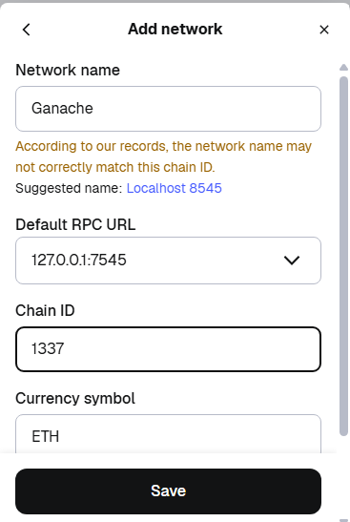

3. Open the Ganache blockchain interface. Copy the secret key for an account. To do so, click the **key** icon next to the first Ethereum test account available in Ganache. Copy the secret key from the popup that appears.

4. Navigate back to your MetaMask wallet. Import the Ethereum account into MetaMask as an account. To do so, click on the account icon (round button next to Account) -> Add account or hardware wallet -> click Private Key and paste Key on => Import

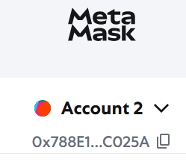 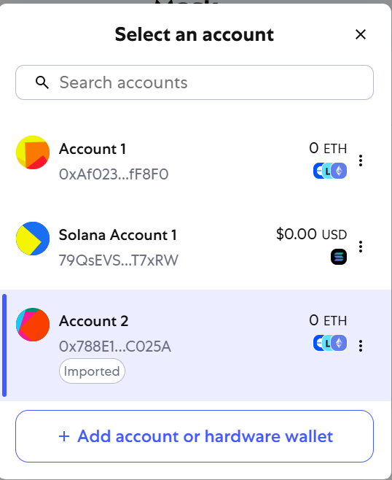 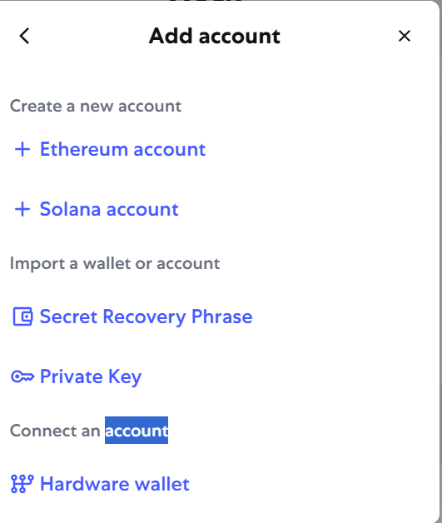 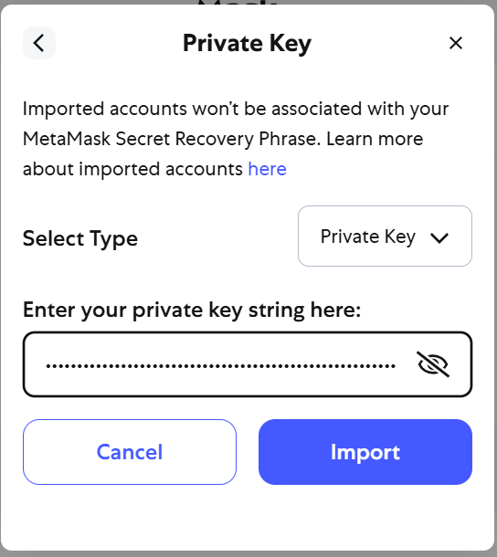

## Step 1: Setting up the React app

Let's start building our React app:

1. We'll first create a new React app called **tokenwallet1** using npx, as shown in the

following:

npx create-react-app tokenwallet1

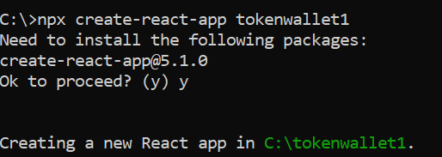

What the command means: Create a new React project named **tokenwallet1**.

* npx: is a tool to run a package from npm without installing it globally.
* create-react-app: is a tool developed by Facebook to quickly initialize a React application with default configuration.
* Tokenwallet1: is the **name of the folder** (and also the name of the application) that will be created.

**If issues appear, run the recommended comand “**npm audit fix --force**”:**

#### 

Once it's done, you'll have a complete React folder structure like this:

Tokenwallet1/

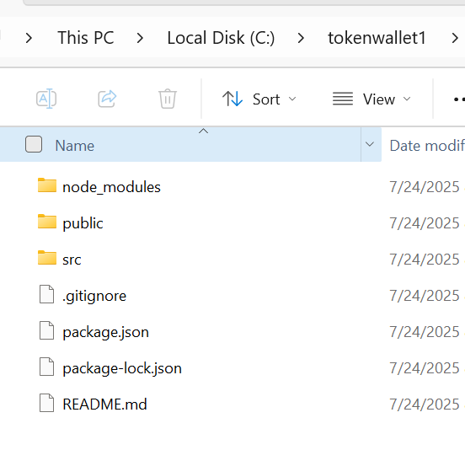

├── node_modules/

├── public/

├── src/

│ └── App.js

├── package.json

├── README.md

└── ...

Purpose: To help you **quickly** **initialize a ReactJS project** without manually configuring Webpack, Babel, or TypeScript, ESLint.

2. Next, we will update package.json (this file is created in the project folder tokenwallet) with the following values:

{

"name": "tokenwallet1",

"version": "1.0.0",

"dependencies": {

"bulma-start": "0.0.2",

"react": "^16.4.2",

"react-dom": "^16.4.2",

"react-scripts": "1.1.4",

"web3": "^1.2.0"

},

"scripts": {

"start": "react-scripts start",

"build": "react-scripts build",

"test": "react-scripts test --env=jsdom",

"eject": "react-scripts eject"

}

}

3. Run the following command to install the dependencies:

npm install

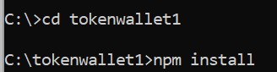

4. Next within the src folder, create a Componentsfolder for the app components. Also, create a Token folder within src. We'll be using this to map the tokens supported by our wallet.

5. Finally, create a folder called Contractsin the src directory. From your build repository in the Truffle workplace, copy the json file for our tokens and the inherited contracts to this folder.

=> This step means you need to bring the JSON files (generated after compiling the smart contract using Truffle) into your React project so you can interact with those smart contracts from the frontend.

Solution 1:

|  |
| --- |
| copy MoolahCoin.json từ tokenwallet\build\contracts sang Tokenwallet1\src\Contracts\  copy Condos.json từ tokenwallet\build\contracts sang Tokenwallet1\src\Contracts\ |

Solution 2:

You can also set symlink instead (auto-update every compile/migrate), to point to the build repository of your Truffle Suit

|  |
| --- |
| mklink /D “C:\tokenwallet1\src\Contracts” “C:\tokenwallet\build\contracts” |



**Note:**

* Do not create a Contracts folder in <link> first
* Run cmd as Administrator

=> Windows will create a link folder at tokenwallet1\src\Contracts **pointing to** tokenwallet\build\contracts. In other words, opening tokenwallet1\src\Contracts will see the contents of tokenwallet\build\contracts.

* mklink is a Windows command that creates symbolic links (symlink).
* mklink [/D] <Link> <Target>:
  + /D: create directory symlink (directory link).
  + <Link>: the link directory path that will be created
  + <Target>: the actual destination containing the data

If you don't have symlink permissions, you can use junction:

mklink /J “C:\tokenwallet1\src\Contracts” “C:\tokenwallet\build\contracts”

Specifically: When you use **Truffle** to compile smart contracts, Truffle will generate **JSON files** located in the directory: truffle-project/build/contracts/

=> These .json files contain the Application Binary Interface (ABI) and the information needed to interact with the smart contract from JavaScript/React (like contract address, bytecode, etc).

## Step 2: Adding token interfaces to our app

We need to map the contract ABI and provide a suitable contract interface that our app can use for invoking the token smart contracts and calling the contract methods.

1. Create folder tokens in app folder (tokenwallet1\src\)

In folder tokens create two components for mapping ERC20 and ERC721 tokens. Let's call these all20.js and all721.js, as shown in the following code:

|  |
| --- |
| //all20.js  import MoolahCoin from './MoolahCoin';  const Tokens20 = [  MoolahCoin  ];  export default Tokens20; |

|  |
| --- |
| //all721.js  import Condos from './Condos';  const Tokens721 = [  Condos  ];  export default Tokens721; |

These files map our MoolahCoin token (ERC20) and Condos token (ERC721). As you add more tokens to the wallet, you need to add them to these files.

2. Next, we'll create two component files for our tokens. We'll label these MoolahCoin.js and Condos.js. These files you create in src/tokens to wrap the token metadata and reference the ABI JSON files above (all20.js and all721.js).

MoolahCoin.js:

|  |
| --- |
| // maps the ERC20 token for the wallet UI  import MC from '../Contracts/MoolahCoin.json';  const NET = '5777'; // Ganache chain id  export default {  address: MC.networks?.[NET]?.address || '',  decimal: 4, // matches your ERC20 decimals()  name: 'Moolah Coin',  symbol: 'MC',  icon: 'MoolahCoin.png', // put an image in /public or /src/assets and adjust path if needed  abi: MC.abi,  }; |

Condos.js:

|  |
| --- |
| // maps the ERC721 token for the wallet UI  import NFT from '../Contracts/Condos.json';  const NET = '5777';  export default {  address: NFT.networks?.[NET]?.address || '',  decimal: 0, // ERC721 not divisible  name: 'Condos',  symbol: 'CONDOS',  icon: 'Condos.jpg',  abi: NFT.abi,  }; |

**After finish Step 2, we have the following files in** tokenwallet1\src\tokens **folder:**

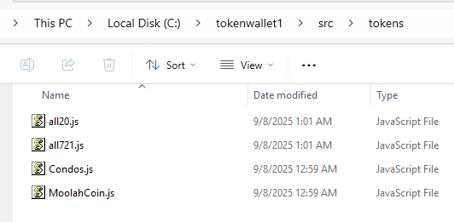

## Step 3: App components

Create new folder src/components and create and add these files to components folder

Following are the main components of our app:

* TokenBlock20.js: This component renders the list of ERC20 tokens along with the option to send, approve, and mint tokens. It renders the token image, symbol, and wallet balance.
* TokenBlock721.js: This component renders the list of ERC721 tokens along with the option to send, approve, and mint tokens. It renders the token image and symbol as well as token ID and metadata. Since this is an ERC721 token, the last two are of special importance here.
* ApproveHeader.js: This component renders the wallet header for the Approve screen. It loads when the user clicks the **approve** button.
* ApproveToken.js: This component renders the wallet screen for the Approve screen. It loads when the user clicks the **approve** button. For ERC20 tokens, it asks for the address to approve and the balance to approve for that address. For ERC721, it asks for the address to approve and the token ID to approve.
* MintHeader.js: This component renders the wallet header for the Mint screen. It loads when the user clicks the **mint** button.
* MintToken.js: This component renders the wallet screen for the Mint screen. It loads when the user clicks the **mint** button. For ERC20 tokens, it asks for the address it needs to send the new tokens to and the number of tokens to mint. For ERC721, it asks for the address to which the new NFT will be tagged and the metadata for the new token.
* TransferHeader.js: This component renders the wallet header for the Transfer screen. It loads when the user clicks the **send** button.
* TransferToken.js: This component renders the wallet screen for the Transfer screen. It loads when the user clicks the **send** button. For ERC20 tokens, it asks for the address to send to and the number of tokens to send. For ERC721, it asks for the address to send to, the ID of the token to be sent, and the new metadata for the transfer.
* InstallMetamask.js: This component notifies the user to install MetaMask when it cannot detect injected web3.

InstallMetamask.js:

|  |
| --- |
| export default function InstallMetamask() {  return (  <div style={{ padding: 16, border: '1px solid #eee', borderRadius: 12 }}>  <h3>MetaMask not detected</h3>  <p>Please install MetaMask and refresh this page.</p>  <a href="https://metamask.io/download/" target="_blank" rel="noreferrer">  Get MetaMask  </a>  </div>  );  } |

TokenBlock20.js:

|  |
| --- |
| import { useEffect, useState } from 'react';  import { ethers } from 'ethers';  import Tokens20 from '../tokens/all20';  export default function TokenBlock20({ onSend, onApprove, onMint }) {  const [account, setAccount] = useState('');  const [balances, setBalances] = useState({}); // { symbol: '123.45' }  useEffect(() => {  (async () => {  if (!window.ethereum) return;  const provider = new ethers.BrowserProvider(window.ethereum);  const signer = await provider.getSigner();  const addr = await signer.getAddress();  setAccount(addr);  const next = {};  for (const t of Tokens20) {  if (!t.address) continue; // chưa migrate  const c = new ethers.Contract(t.address, t.abi, provider);  const raw = await c.balanceOf(addr);  next[t.symbol] = ethers.formatUnits(raw, t.decimals ?? 18);  }  setBalances(next);  })();  }, []);  if (!window.ethereum) return null;  return (  <div style={{ display: 'grid', gap: 12 }}>  {Tokens20.map((t) => (  <div key={t.symbol} style={{ padding: 12, border: '1px solid #eee', borderRadius: 12 }}>  <div style={{ display: 'flex', alignItems: 'center', gap: 12 }}>  <img src={`/assets/${t.icon || 'erc20.png'}`} alt={t.symbol} width={28} height={28} />  <div style={{ fontWeight: 600 }}>{t.name} <small>({t.symbol})</small></div>  <div style={{ marginLeft: 'auto' }}>  {balances[t.symbol] ?? '--'} {t.symbol}  </div>  </div>  <div style={{ marginTop: 8, display: 'flex', gap: 8 }}>  <button onClick={() => onSend?.(t, account)}>Send</button>  <button onClick={() => onApprove?.(t, account)}>Approve</button>  <button onClick={() => onMint?.(t, account)}>Mint</button>  </div>  </div>  ))}  </div>  );  } |

TokenBlock721.js:

|  |
| --- |
| import { useEffect, useState } from 'react';  import { ethers } from 'ethers';  import Tokens721 from '../tokens/all721';  export default function TokenBlock721({ onSend, onApprove, onMint }) {  const [account, setAccount] = useState('');  const [counts, setCounts] = useState({}); // { symbol: number }  useEffect(() => {  (async () => {  if (!window.ethereum) return;  const provider = new ethers.BrowserProvider(window.ethereum);  const signer = await provider.getSigner();  const addr = await signer.getAddress();  setAccount(addr);  const next = {};  for (const t of Tokens721) {  if (!t.address) continue;  const c = new ethers.Contract(t.address, t.abi, provider);  const balance = await c.balanceOf(addr);  next[t.symbol] = Number(balance);  }  setCounts(next);  })();  }, []);  if (!window.ethereum) return null;  return (  <div style={{ display: 'grid', gap: 12 }}>  {Tokens721.map((t) => (  <div key={t.symbol} style={{ padding: 12, border: '1px solid #eee', borderRadius: 12 }}>  <div style={{ display: 'flex', alignItems: 'center', gap: 12 }}>  <img src={`/assets/${t.icon || 'erc721.png'}`} alt={t.symbol} width={28} height={28} />  <div style={{ fontWeight: 600 }}>{t.name} <small>({t.symbol})</small></div>  <div style={{ marginLeft: 'auto' }}>{counts[t.symbol] ?? 0} owned</div>  </div>  <div style={{ marginTop: 8, display: 'flex', gap: 8 }}>  <button onClick={() => onSend?.(t, account)}>Send</button>  <button onClick={() => onApprove?.(t, account)}>Approve</button>  <button onClick={() => onMint?.(t, account)}>Mint</button>  </div>  </div>  ))}  </div>  );  } |

ApproveHeader.js:

|  |
| --- |
| export default function ApproveHeader() {  return <h2 style={{ margin: '12px 0' }}>Approve</h2>;  } |

ApproveToken.js:

|  |
| --- |
| import { useEffect, useState } from 'react';  import { ethers } from 'ethers';  export default function ApproveToken({ token }) {  const [account, setAccount] = useState('');  const [spender, setSpender] = useState('');  const [amount, setAmount] = useState(''); // ERC20  const [tokenId, setTokenId] = useState(''); // ERC721  const [status, setStatus] = useState('');  useEffect(() => {  (async () => {  if (!window.ethereum) return;  const provider = new ethers.BrowserProvider(window.ethereum);  const signer = await provider.getSigner();  setAccount(await signer.getAddress());  })();  }, []);  if (!token) return null;  async function handleApprove() {  try {  if (!window.ethereum) return;  const provider = new ethers.BrowserProvider(window.ethereum);  const signer = await provider.getSigner();  const c = new ethers.Contract(token.address, token.abi, signer);  if (token.decimals !== undefined) {  // ERC20  const value = ethers.parseUnits(amount || '0', token.decimals);  const tx = await c.approve(spender, value);  setStatus('Waiting for confirmation...');  await tx.wait();  setStatus('Approved successfully.');  } else {  // ERC721  const id = BigInt(tokenId);  const tx = await c.approve(spender, id);  setStatus('Waiting for confirmation...');  await tx.wait();  setStatus('Approved successfully.');  }  } catch (e) {  setStatus(e.message || String(e));  }  }  return (  <div style={{ display: 'grid', gap: 8 }}>  <div>Token: <strong>{token.name}</strong> ({token.symbol})</div>  <label>Spender / Operator</label>  <input value={spender} onChange={e => setSpender(e.target.value)} placeholder="0x..." />  {token.decimals !== undefined ? (  <>  <label>Amount ({token.symbol})</label>  <input value={amount} onChange={e => setAmount(e.target.value)} placeholder="e.g., 100" />  </>  ) : (  <>  <label>Token ID</label>  <input value={tokenId} onChange={e => setTokenId(e.target.value)} placeholder="e.g., 0" />  </>  )}  <button onClick={handleApprove}>Approve</button>  <small style={{ color: '#666' }}>From: {account}</small>  {status && <div style={{ marginTop: 6 }}>{status}</div>}  </div>  );  } |

MintHeader.js:

|  |
| --- |
| export default function MintHeader() {  return <h2 style={{ margin: '12px 0' }}>Mint</h2>;  } |

MintToken.js:

|  |
| --- |
| import { useEffect, useState } from 'react';  import { ethers } from 'ethers';  export default function MintToken({ token }) {  const [to, setTo] = useState('');  const [amount, setAmount] = useState(''); // ERC20  const [uri, setUri] = useState(''); // ERC721  const [status, setStatus] = useState('');  useEffect(() => {  (async () => {  if (!window.ethereum) return;  const provider = new ethers.BrowserProvider(window.ethereum);  const signer = await provider.getSigner();  const addr = await signer.getAddress();  setTo(addr); // mặc định mint về chính mình  })();  }, []);  if (!token) return null;  async function handleMint() {  try {  if (!window.ethereum) return;  const provider = new ethers.BrowserProvider(window.ethereum);  const signer = await provider.getSigner();  const c = new ethers.Contract(token.address, token.abi, signer);  // Một số ERC20 (ví dụ trong sách) có hàm mint(owner-only). Nếu contract không có, bắt lỗi đẹp.  if (token.decimals !== undefined) {  if (!c.mint) throw new Error('This ERC20 does not expose a public mint()');  const value = ethers.parseUnits(amount || '0', token.decimals);  const tx = await c.mint(to, value);  setStatus('Waiting for confirmation...');  await tx.wait();  setStatus('Minted successfully.');  } else {  // ERC721 Condos: mint(to, uri)  const tx = await c.mint(to, uri);  setStatus('Waiting for confirmation...');  await tx.wait();  setStatus('Minted successfully.');  }  } catch (e) {  setStatus(e.message || String(e));  }  }  return (  <div style={{ display: 'grid', gap: 8 }}>  <div>Token: <strong>{token.name}</strong> ({token.symbol})</div>  <label>Recipient</label>  <input value={to} onChange={e => setTo(e.target.value)} placeholder="0x..." />  {token.decimals !== undefined ? (  <>  <label>Amount ({token.symbol})</label>  <input value={amount} onChange={e => setAmount(e.target.value)} placeholder="e.g., 1000" />  </>  ) : (  <>  <label>Metadata URI</label>  <input value={uri} onChange={e => setUri(e.target.value)} placeholder="https://..." />  </>  )}  <button onClick={handleMint}>Mint</button>  {status && <div style={{ marginTop: 6 }}>{status}</div>}  </div>  );  } |

TransferHeader.js:

|  |
| --- |
| export default function TransferHeader() {  return <h2 style={{ margin: '12px 0' }}>Transfer</h2>;  } |

TransferToken.js:

|  |
| --- |
| import { useEffect, useState } from 'react';  import { ethers } from 'ethers';  export default function TransferToken({ token }) {  const [from, setFrom] = useState('');  const [to, setTo] = useState('');  const [amount, setAmount] = useState(''); // ERC20  const [tokenId, setTokenId] = useState(''); // ERC721  const [status, setStatus] = useState('');  useEffect(() => {  (async () => {  if (!window.ethereum) return;  const provider = new ethers.BrowserProvider(window.ethereum);  const signer = await provider.getSigner();  const addr = await signer.getAddress();  setFrom(addr);  })();  }, []);  if (!token) return null;  async function handleTransfer() {  try {  if (!window.ethereum) return;  const provider = new ethers.BrowserProvider(window.ethereum);  const signer = await provider.getSigner();  const c = new ethers.Contract(token.address, token.abi, signer);  if (token.decimals !== undefined) {  // ERC20  const value = ethers.parseUnits(amount || '0', token.decimals);  const tx = await c.transfer(to, value);  setStatus('Waiting for confirmation...');  await tx.wait();  setStatus('Transferred successfully.');  } else {  // ERC721  const id = BigInt(tokenId);  const tx = await c['safeTransferFrom(address,address,uint256)'](from, to, id);  setStatus('Waiting for confirmation...');  await tx.wait();  setStatus('Transferred successfully.');  }  } catch (e) {  setStatus(e.message || String(e));  }  }  return (  <div style={{ display: 'grid', gap: 8 }}>  <div>Token: <strong>{token.name}</strong> ({token.symbol})</div>  <label>From</label>  <input value={from} onChange={e => setFrom(e.target.value)} placeholder="0x..." />  <label>To</label>  <input value={to} onChange={e => setTo(e.target.value)} placeholder="0x..." />  {token.decimals !== undefined ? (  <>  <label>Amount ({token.symbol})</label>  <input value={amount} onChange={e => setAmount(e.target.value)} placeholder="e.g., 25" />  </>  ) : (  <>  <label>Token ID</label>  <input value={tokenId} onChange={e => setTokenId(e.target.value)} placeholder="e.g., 0" />  </>  )}  <button onClick={handleTransfer}>Send</button>  {status && <div style={{ marginTop: 6 }}>{status}</div>}  </div>  );  } |

**After finish Step 3, we have the following files in** tokenwallet1\src\components **folder:**

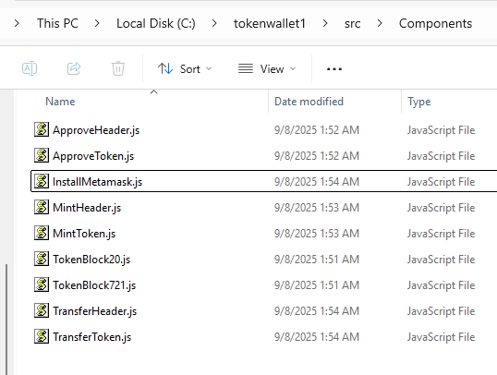

## Step 4: Running our app

Let's bring our wallet online and run the application to see how it works. Make sure your Ganache blockchain is running and the contracts are deployed. Let's run our React development server:

1. Run the following command in the project directory:

npm start

By default, the app should run on port 3000.

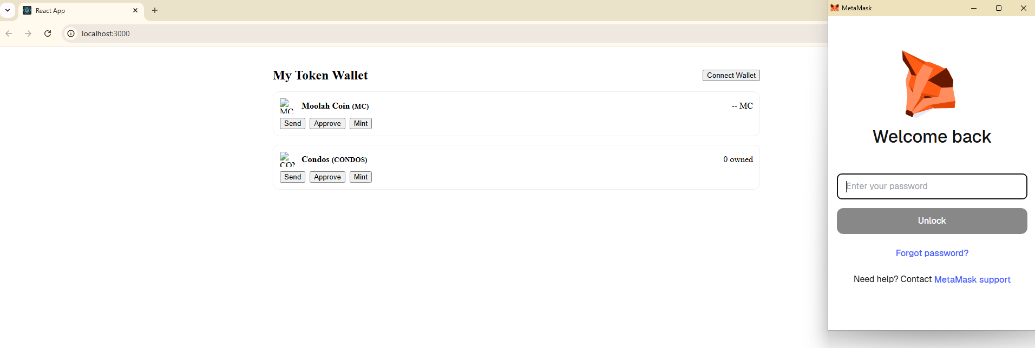

2. You need to sign in with your MetaMask credentials so the app can access your primary account. After signing in, you should get another popup, as shown in the following screenshot. You need to permit the app access to MetaMask: Click **Connect**

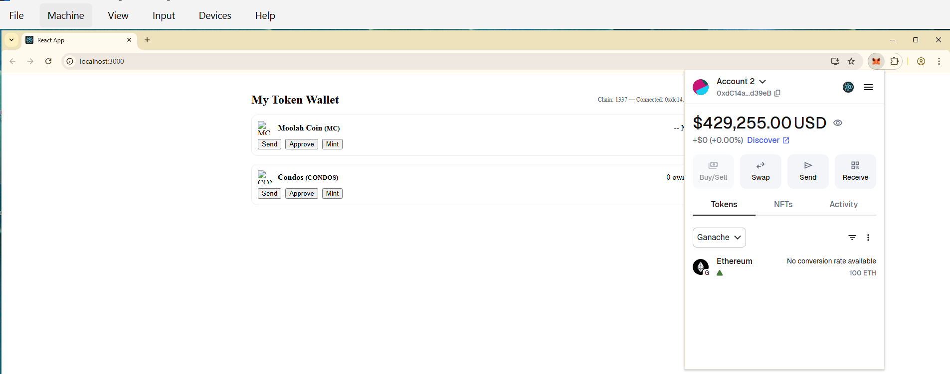

3. Next, we will add the Condos and MoolahCoin tokens to your MetaMask wallet. Choose tab **Tokens** => Click on the **three dots** in the right corner, select **Import tokens**

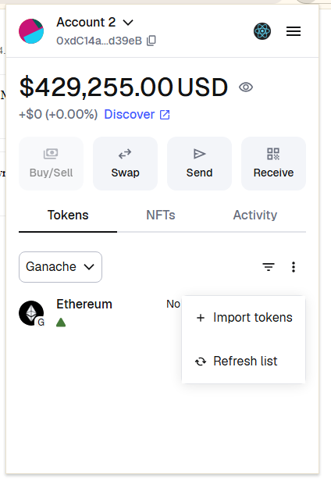

Add MoolahCoin token and see the result:

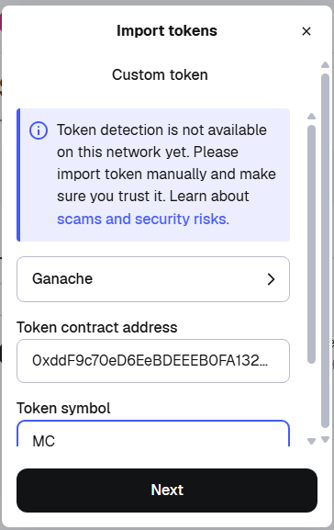 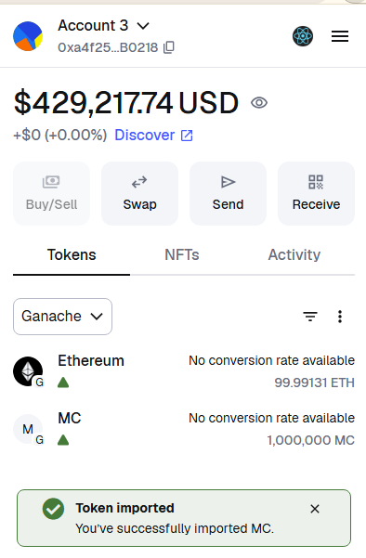

Add Condos token (in tab **NFTs**)

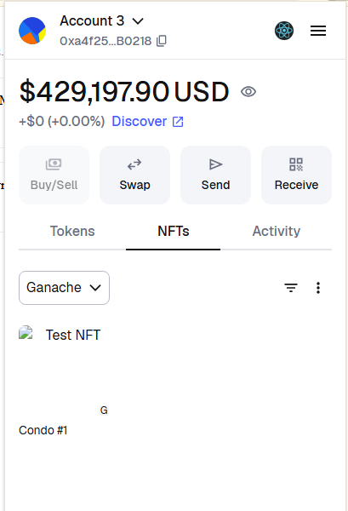

4. We need to mint an initial amount of tokens to ourselves before we start using the app. To do so, navigate back to the Truffle console and run the following code:

//Mint 10 MoolahCoins

MoolahCoin.deployed().then(function(instance) { return

instance.mint("<Your primary eth address>",100000);

}).then(function(responseb) {console.log("response",

responseb.toString(10));});

//Mint 1 Condo Token with metadata 'New Delhi'

Condos.deployed().then(function(instance) { return

instance.createNFT("<Your primary eth address>","New Delhi");

}).then(function(responseb) {console.log("response",

responseb.toString(10));});

Our token wallet app will now look like the following screenshot:



You will now see the MoolahCoin and Condo tokens in your wallet dashboard.

5. Let's try to send some tokens now. Click on the **Send** button for MC. The send MC screen will open as shown in the following screenshot:



6. Copy an address from the list of auto-generated addresses from Ganache, as shown in the following screenshot:



7. Copy the receiver's address field, enter an amount to transfer, and click on **Send**. MetaMask will pop up with a notification and ask the user's permission to transfer tokens:



8. Click on **Confirm** and the transaction will go through. MetaMask will give you a pop-up notification to let you know the transaction has gone through successfully. The balance change is reflected in the app interface:



9. Let's try to approve now. Click on the **Approve** button for MoolahCoin. Enter an address to approve and the token balance permitted to move. Click on **Confirm** after entering the details, as shown in the following screenshot:



MetaMask asks for the user's permission. It also shows a notification indicating that the user is approving another address to spend tokens on their behalf. Click on **Confirm** for approval to go through.

10. Lastly, let's try out the Mint operation for the Condos token. As shown in the following screenshot, Mint allows you to create and assign new tokens to an Ethereum address. Click on the **Mint** button for Condos to get the **MINT** token screen. Enter an address to mint the new tokens to. Minting for Condos also allows you to allocate an initial metadata value to the token:



11. Click on **Mint** after entering the address and metadata as shown in the following screenshot. MetaMask pops up with a notification asking for the user's permission:



12. Click on **Confirm** to generate a new NFT mapped to the receiving address with the metadata mentioned on the screen.

# V. CONNECTING TO THE MAIN ETHEREUM NETWORK

In this section, we'll see how our wallet can be connected to the main Ethereum network and used for storing, transferring, and managing fungible and non-fungible assets on the Ethereum network:

1. To deploy the wallet and contracts in production, you need to have a geth instance running on the main Ethereum network. Geth is a popular Ethereum client used to run an Ethereum node and connect to the main network. Update the truffle-config.js file to point to the production geth instance as shown in the following. The network ID is set to 1 for the main network:

const HDWalletProvider = require('truffle-hdwallet-provider');

module.exports = {

networks: {

development: {

host: "127.0.0.1",

port: 8545,

network_id: "*",

}

prod: {

host: "<Live geth host IP>",

port: 8545,

network_id: "1",

}

},

compilers: {

solc: {

version: "0.5.2",

settings: {

optimizer" {

enabled: false,

runs: 1000,

},

}}}}}

2. Run the following command to launch an instance of the Truffle console pointed to your production geth instance:

truffle prod

3. Make sure your coinbase is set and your account is unlocked before executing migrate. Since you are deploying on the main Ethereum network, there will be associated gas that you need to pay to the network. Make sure your account has sufficient ethers to pay for gas. Run the following command to unlock your account:

personal.unlockAccount(eth.accounts[0],'passphrase',1000)

4. Run migrate on the console to deploy your contracts to the production geth:

migrate

5. Let's come to the app now. Point the MetaMask instance to the main Ethereum network by selecting it from the drop-down list as shown in the following screenshot:



Your wallet app should now be connected to the main Ethereum network. This is indicated on the network status tab, as shown in the following screenshot:



You can now start using your wallet app on the main Ethereum network.